**Chapter 1**

**Ultrasonic sensor with Arduino Nano**

**What is the ultrasonic sensor?**

The HC-SR04 ultrasonic sensor uses sonar to determine the distance to an object. This sensor reads from 2cm to 400cm (0.8inch to 157inch) with an accuracy of 0.3cm (0.1inches), which is good for most hobbyist projects. In addition, this particular module comes with ultrasonic transmitter and receiver modules

**Features**

* Power Supply :+5V DC
* Quiescent Current : <2mA
* Working Current: 15mA
* Effectual Angle: <15°
* Ranging Distance : 2cm – 400 cm/1″ – 13ft
* Resolution : 0.3 cm
* Measuring Angle: 30 degree
* Trigger Input Pulse width: 10uS TTL pulse
* Echo Output Signal: TTL pulse proportional to the distance range
* Dimension: 45mm x 20mm x 15mm

### 

### **Chapter 2**

**Components and Pin Description**

### **Components**

* Arduino Nano board
* Ultrasonic sensor
* Breadboard
* Jumper Wires
* USB Cable

### **Pinout of the HC-SR04 Ultrasonic Sensor.**

The HC-SR04 ultrasonic sensor consists of a transmitter and a receiver, as well as a control circuit and a power supply. The transmitter sends out a high-frequency sound pulse, while the receiver listens for the pulse to bounce back after it hits an object.

To measure distance, the Arduino sends a pulse to the trigger pin of the HC-SR04 sensor, causing the transmitter to emit a sound pulse. The sound pulse travels through the air and hits an object, causing it to bounce back to the receiver.

The receiver measures the time it takes for the sound pulse to bounce back and sends this information to the control circuit. The control circuit calculates the distance to the object based on the time delay and the speed of sound.

The Arduino can then read the distance measurement from the sensor by reading the value on the echo pin. This value is proportional to the distance to the object, and the Arduino can use it to calculate the actual distance.

To detect objects, the Arduino can simply check whether the distance measured by the sensor is below a certain threshold. If the distance is below the threshold, it means that there is an object within range of the sensor.

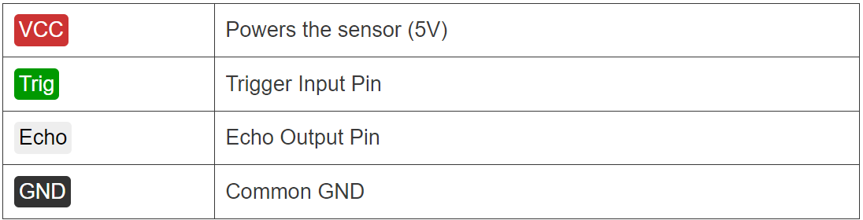

## **HC-SR04 Ultrasonic Distance Sensor Works**

It emits an ultrasound at 40 000 Hz which travels through the air and if there is an object or obstacle on its path It will bounce back to the module. Considering the travel time and the speed of the sound you can calculate the distance.

In order to generate the ultrasound we need to set the Trig pin on a High State for 10 µs. That will send out an 8 cycle ultrasonic burst which will travel at the [speed of sound](https://en.wikipedia.org/wiki/Speed_of_sound). The Echo pins goes high right away after that 8 cycle ultrasonic burst is sent, and it starts listening or waiting for that wave to be reflected from an object.

If there is no object or reflected pulse, the Echo pin will time-out after 38ms and get back to low state.

If we receive a reflected pulse, the Echo pin will go down sooner than those 38ms. According to the amount of time the Echo pin was HIGH, we can determine the distance the sound wave traveled, thus the distance from the sensor to the object.

**Arduino Nano**

### **Technical Specifications**

* The technical specifications of the Arduino Nano board are:
* The operating voltage of the Nano board varies from 5V to 12V.
* The total pins in Nano are 22 Input/Output pins.
* There are 14 digital pins and 8 analog pins.
* There are 6 PWM (Pulse Width Modulation) pins among the 14 digital pins. The 6 PWM pins in Arduino Nano are used to convert the digital signals into the analog signals. The conversion takes place by varying the width of the pulse.
* The crystal oscillator present in Arduino Nano comes with a frequency of 16MHz.
* The Arduino Nano is used in various applications such as **Robotics, Control System, Instrumentation, Automations, and Embedded Systems.**
* The projects created using Arduino Nano are **QR Code Scanner, DIY Arduino Pedometer, etc.**
* We can also connect Arduino Nano to the Wifi.
* The functionality of Nano is similar to the Arduino UNO.
* The flexibility and eco-friendly nature of Nano make it a unique choice to create electronic devices and projects with compact size.

**Arduino Nano board**

Arduino Nano has similar functionalities as Arduino Duemilanove but with a different package. The Nano is inbuilt with the ATmega328P microcontroller, same as the Arduino UNO. The main difference between them is that the UNO board is presented in PDIP (Plastic Dual-In-line Package) form with 30 pins and Nano is available in TQFP (plastic quad flat pack) with 32 pins. The extra 2 pins of Arduino Nano serve for the ADC functionalities, while UNO has 6 ADC ports but Nano has 8 ADC ports.  The Nano board doesn’t have a DC power jack as other Arduino boards, but instead has a mini-USB port. This port is used for both programming and serial monitoring. The fascinating feature in Nano is that it will choose the strongest power source with its potential difference, and the power source selecting jumper is invalid.

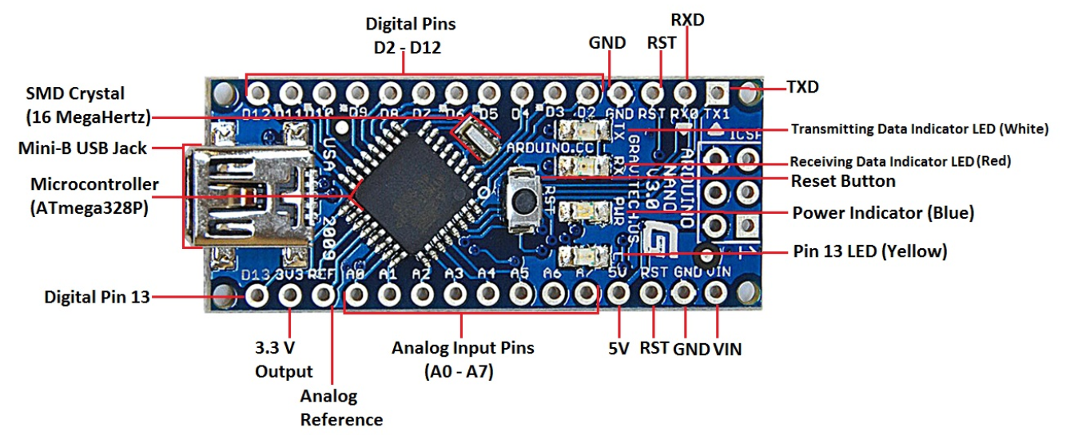

**Chapter 3**

**Implementation**

**Step 1**

Identify and Connect the components

**Arduino Nano board**

* The Arduino Nano board is a very low-cost board. That is why I have used this board. You can use any other Arduino board for this project.

**Ultrasonic Sensor**

* This component has been described above.

**Breadboard**

* This is used for the easy mounting of the component.

**Jumper Wires**

* I have used four male to male upper wires.

**USB**

* It is used to connect the Arduino board to the computer.

**Step 2**

Connect the ultrasonic sensor and the Arduino board to the breadboard.

**Step 3**

OK, we connect the ultrasonic sensor to the Arduino board using the jumper wire.

**Step 4**

Okay, let’s look at the code below.

#include <LiquidCrystal.h> // includes the LiquidCrystal Library

LiquidCrystal lcd(1, 2, 4, 5, 6, 7); // Creates an LCD object. Parameters: (rs, enable, d4, d5, d6, d7)

const int trigPin = 9;

const int echoPin = 10;

long duration;

int distanceCm, distanceInch;

void setup() {

lcd.begin(16, 2); // Initializes the interface to the LCD screen, and specifies the dimensions (width and height) of the display

pinMode(trigPin, OUTPUT);

pinMode(echoPin, INPUT);

}

void loop() {

digitalWrite(trigPin, LOW);

delayMicroseconds(2);

digitalWrite(trigPin, HIGH);

delayMicroseconds(10);

digitalWrite(trigPin, LOW);

duration = pulseIn(echoPin, HIGH);

distanceCm = duration * 0.034 / 2;

distanceInch = duration * 0.0133 / 2;

lcd.setCursor(0, 0); // Sets the location at which subsequent text written to the LCD will

lcd.print("Distance: "); // Prints string "Distance" on the LCD

lcd.print(distanceCm); // Prints the distance value from the sensor

lcd.print(" cm");

delay(10);

lcd.setCursor(0, 1);

lcd.print("Distance: ");

lcd.print(distanceInch);

lcd.print(" inch");

delay(10);

}

**Step 5**

Select board and port.

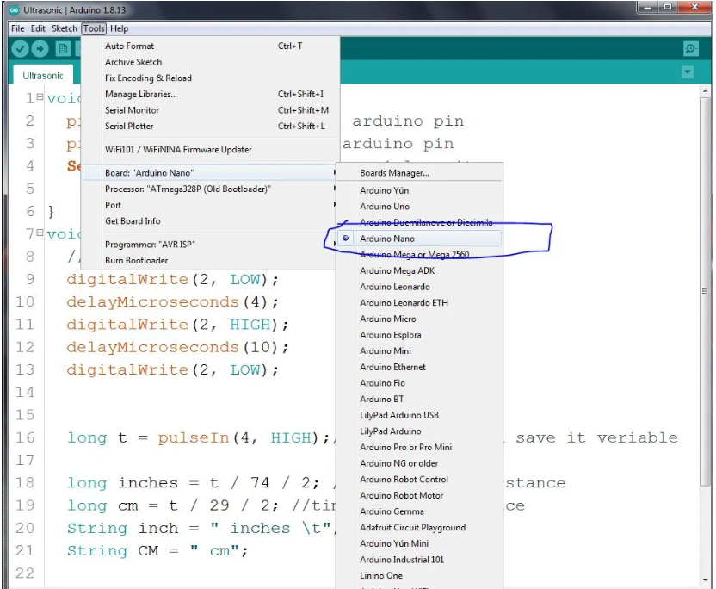

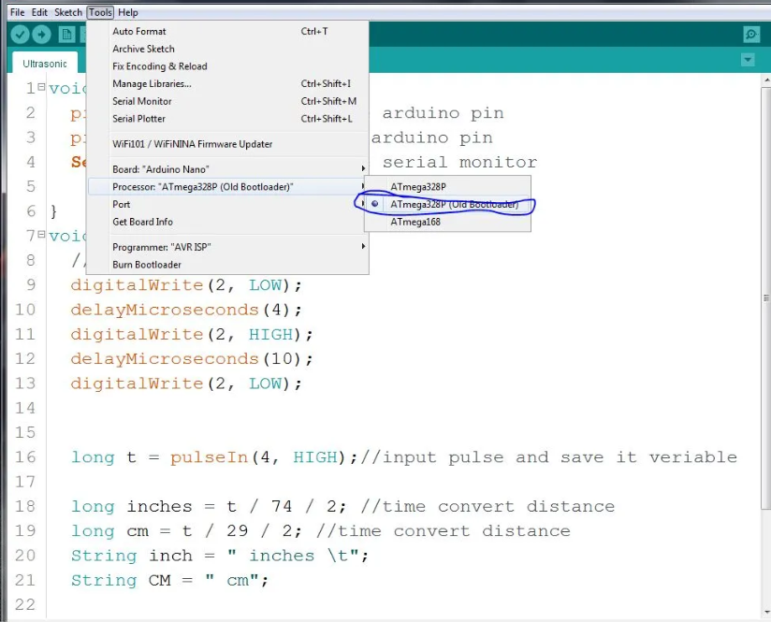

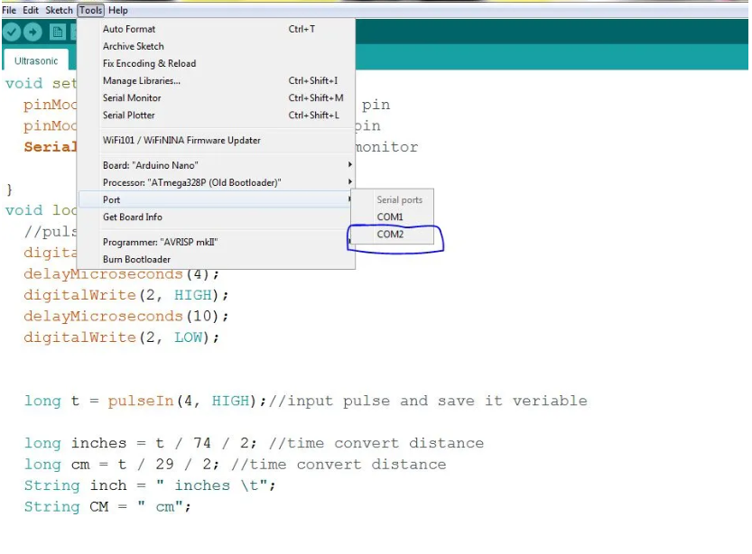**Step 6**

Now, upload this code and run the Serial monitor.

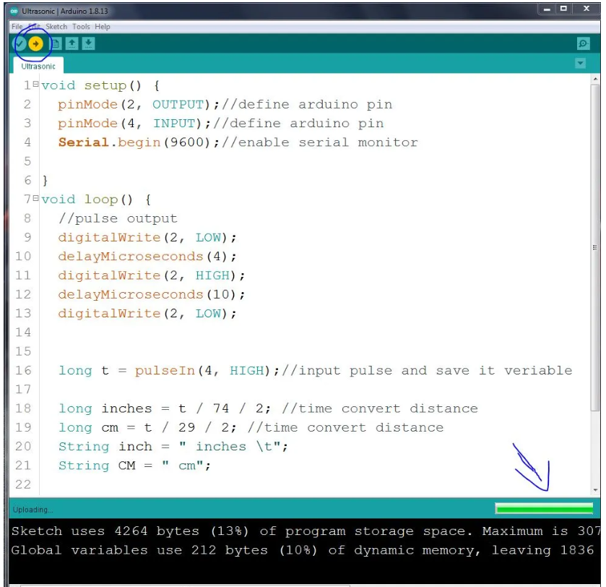

## **Chapter 4**

## **Conclusion**

Ultrasonic HC-SR04 sensor can measure distance using the Arduino code. It measures accurate distance of objects and is widely used in DIY projects. This article covered a detailed guide on working and interfacing of ultrasonic sensors with Arduino Nano boards. For further information read the article.

**REFERENCES**

[1]. “Basic circuit Analysis” by k.v.v murthy

[2]. Digital circuit /Digital Integrated Budronies “by H.Taub D .schilling

[3]. “Transduces & instrumentation”(sensory by D.V.S mothy

[4]. <https://srituhobby.com/ultrasonic-sensor-with-arduino-nano-how-does-work-ultrasonic-sensor/>

[5]. https://howtomechatronics.com/tutorials/arduino/ultrasonic-sensor-hc-sr04/